SAVE the DATE
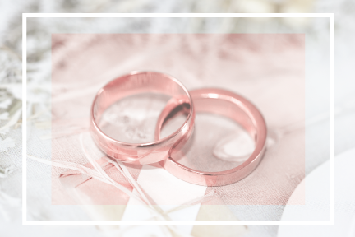

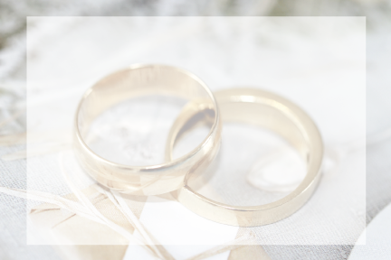
YOU ARE JOYFULLY INVITED
To the wedding celebration of
LAURA and PETER
00/00/00
00:00 PM

Address

